Practical No.1
Aim: SELECT Queries
a) Select queries on single table using alias, where and order by clause.
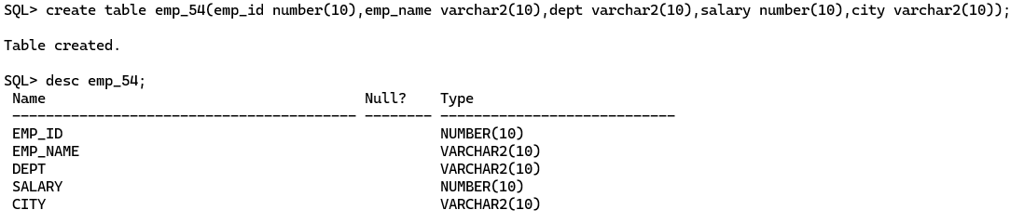
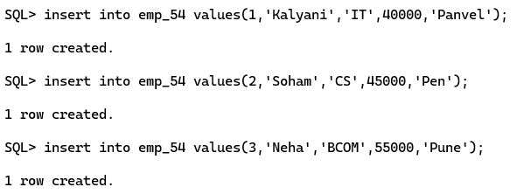
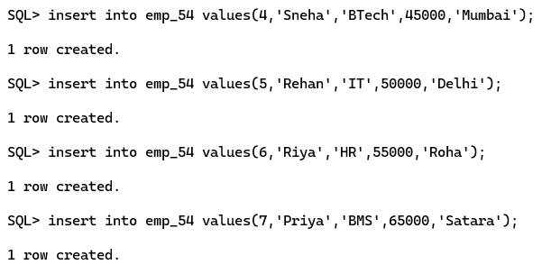
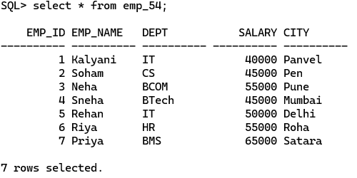
1. Select Query Using Alias
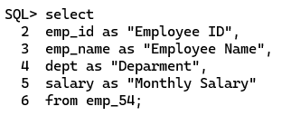
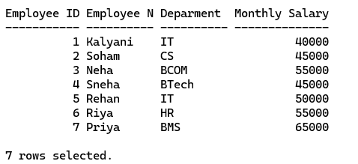
2. Select Query Using WHERE clause
- Display employee whose salary is greater than 40,000.
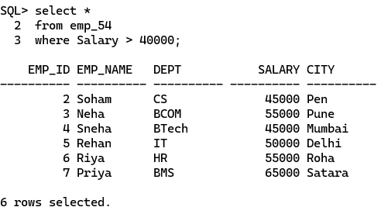
3. Select Query Using ORDER BY Clause
- Display employee records in ascending order of salary.
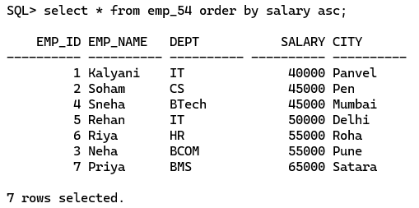

- Or, to display in descending order;
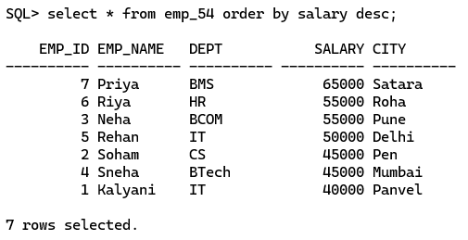

4. Select Query Using Alias + WHERE + ORDER BY
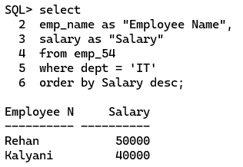

5. PL/SQL Block Using SELECT INTO
- Retrieve the salary of an employee.
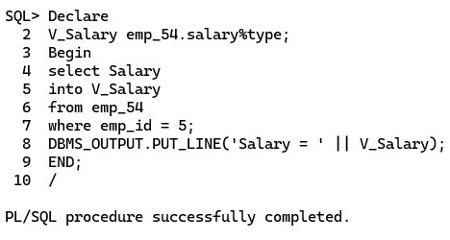

b) Select queries on single table using aggregate function.
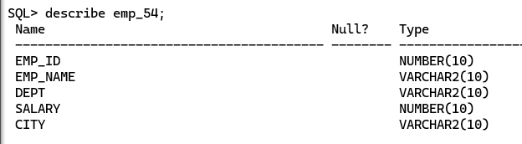
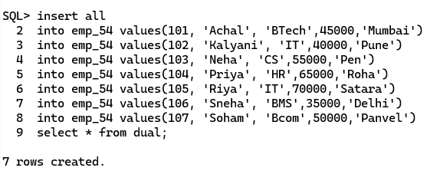
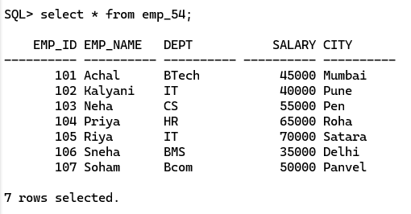

1. COUNT() Function
Count the total number of employees.
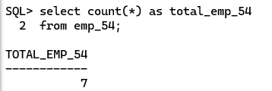
2. SUM() Function
Calculate the total salary of all employees.
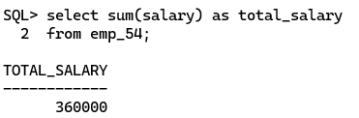
3. AVG() Function
Find the average salary of employees.
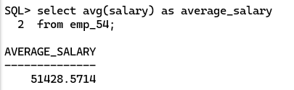

4. MAX() Function
Find the highest salary.
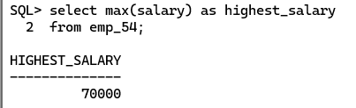

5. MIN() Function
Find the lowest salary.
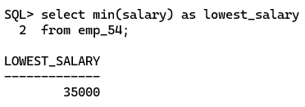
6. Aggregate Function with WHERE Clause
Find the average salary of employees in the IT department.
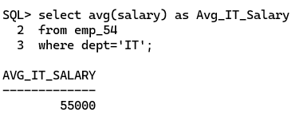
7. Aggregate Function with GROUP BY
Count the sum of employees in each department.
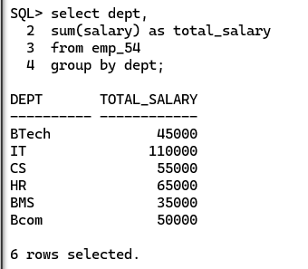

8. Aggregate Function with GROUP BY and COUNT()
Count the number of employees in each department.
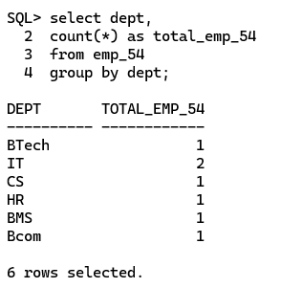

9. Aggregate Function with GROUP BY and ORDER BY
Display the average salary of each department in descending order.
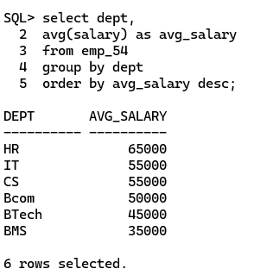
Practical No.2
Aim: Implimenting DML & DDL Statement.
A. Manipulating data (Insert, Update, Delete & Close).
a) Creating a simple table
Describe the table
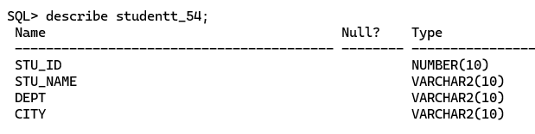
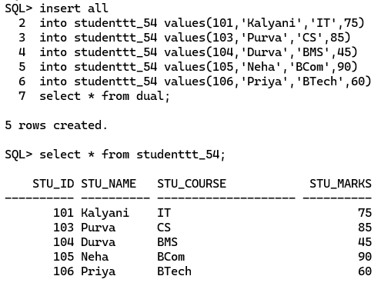

B. Creating a table with constraints
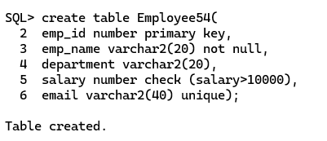
Describe Table
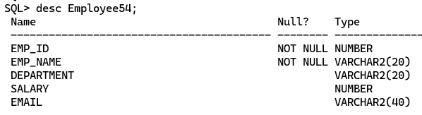
C. Insert Operation
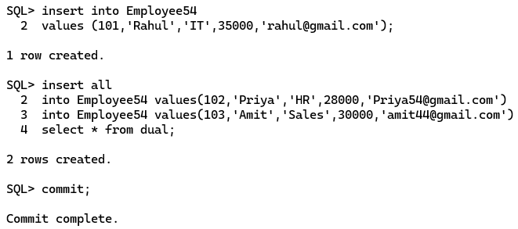

Display Records
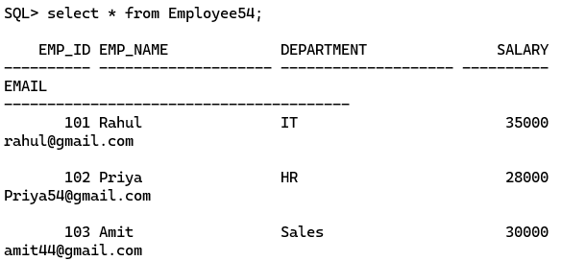

D. Update Operation
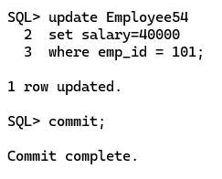
E. Delete Operation
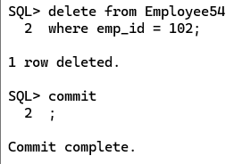
Practical No.4(A)
Aim: Write a PL/SQL program to print a message.
Output:
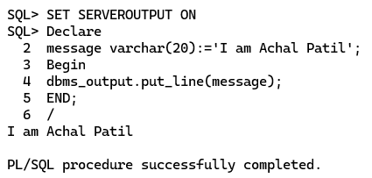

Practical No.4(B)
Aim: Write PL/SQL program for the addition of two number.
Output:
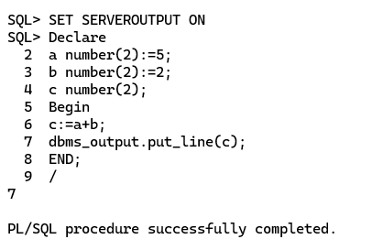

Practical No.4(C)
Aim: Write a PL/SQL program to calculate area and circumference of circle.
Output:
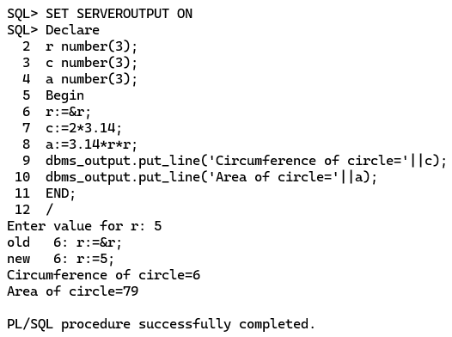

Practical No. 4(D)
Aim: Write a PL/SQL program to calculate area of square.
Output:
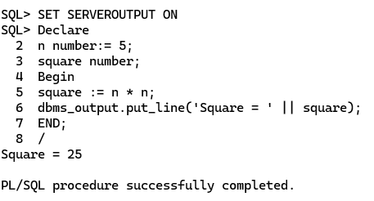

Practical No. 4(E)
Aim: Write a PL/SQL program to calculate simple interest.
Output:
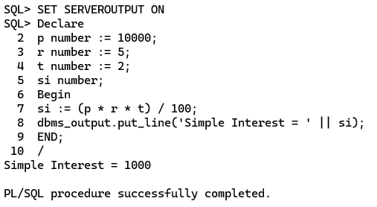

Practical No. 4(F)
Aim: Write a PL/SQL program to swap two number.
Output:
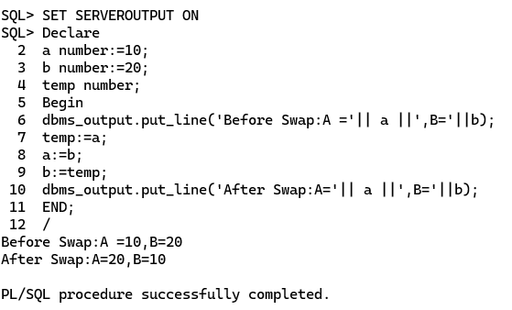

Practical No.3
Aim: Select queries using joins
Querying data from multiple tables using all types of Joins
a) Department Table
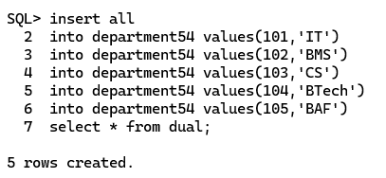
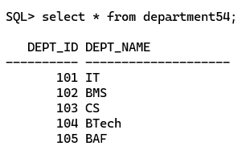

b) Employee Table

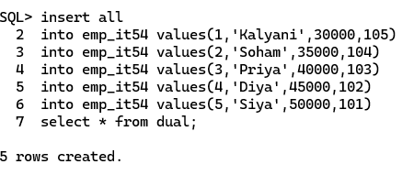
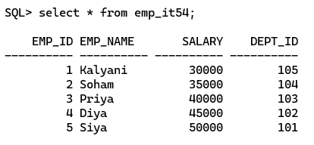
1. Inner Join
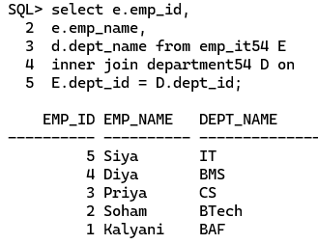

2. Left Outer Join
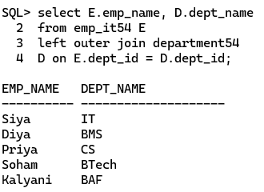

3. Right Outer Join
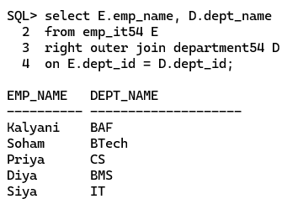

4. Full Outer Join
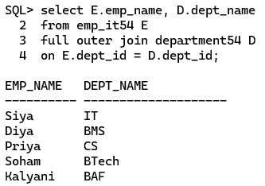
5. Cross Outer Join
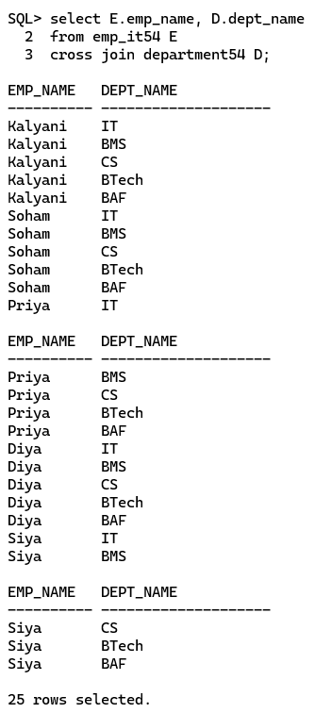
Practical No. 5(A)
Aim: Write PL/SQL program using control structures.
Simple Loop
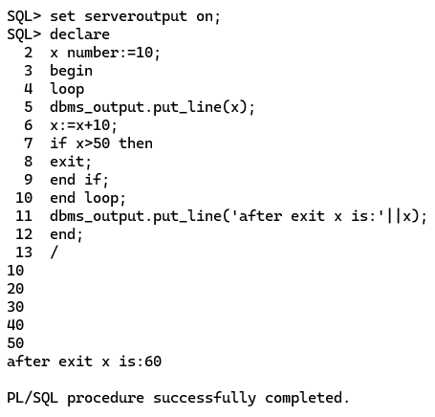

Practical No. 5(B)
Aim: Write PL/SQL program using control structures.
While Loop
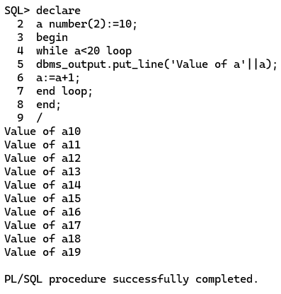

Practical No. 5(C)
Aim: Write PL/SQL program using control structures.
For Loop
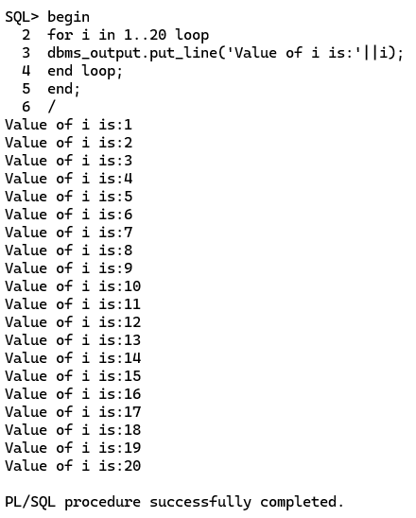

Practical No. 5(D)
Aim: Write PL/SQL program using control structures.
If then Else
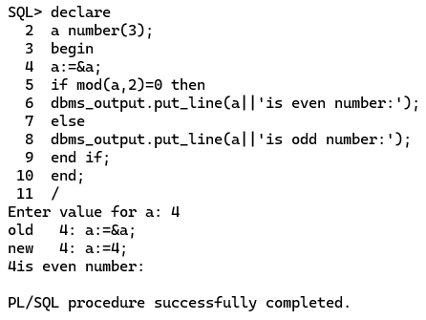

Practical No.6
Aim: Implementing Pre-define and User-define Exception Handling.
1. Pre-define-exception
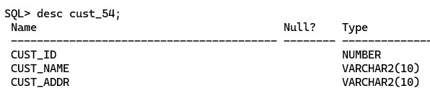
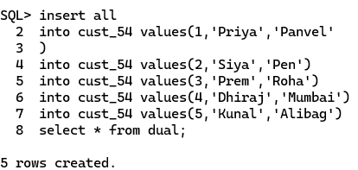
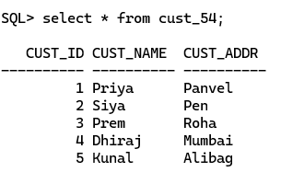

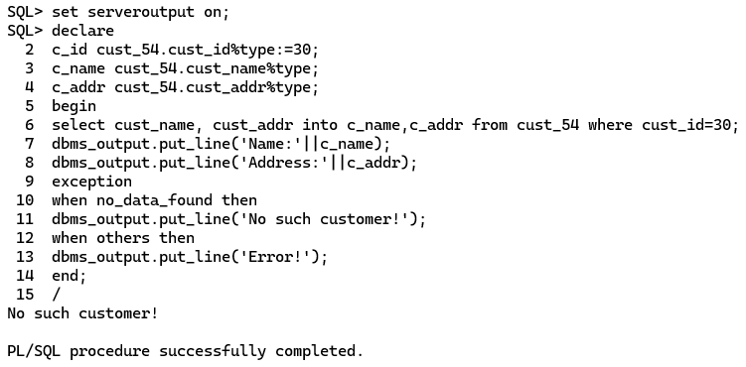
2. User-define-exception
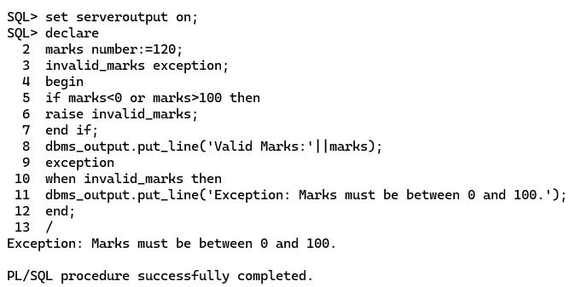

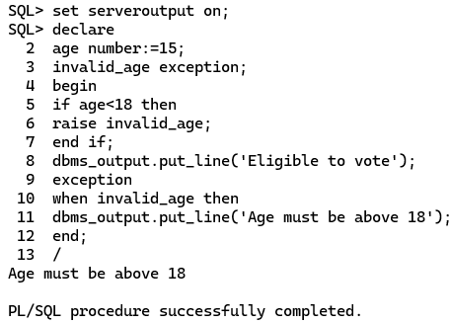

Practical No.7
Aim: Implementing Cursors (Implicit Cursor & Explicit Cursor).
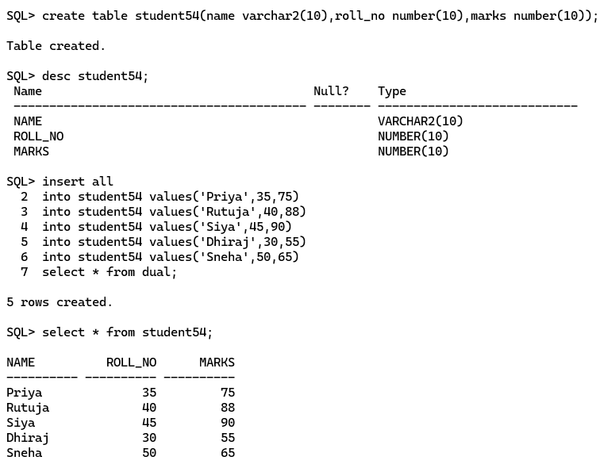
1. Implicit Cursor
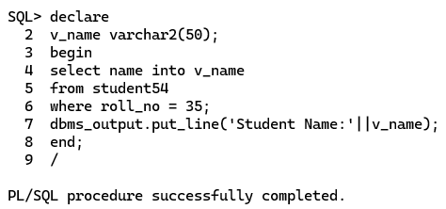
2. Update Cursor Attribute
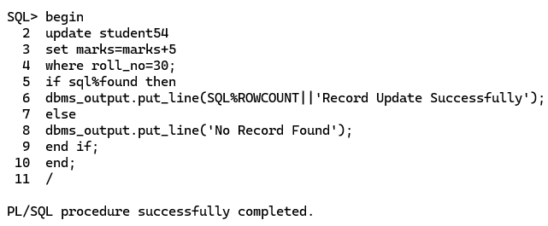

3. Explicit Cursor
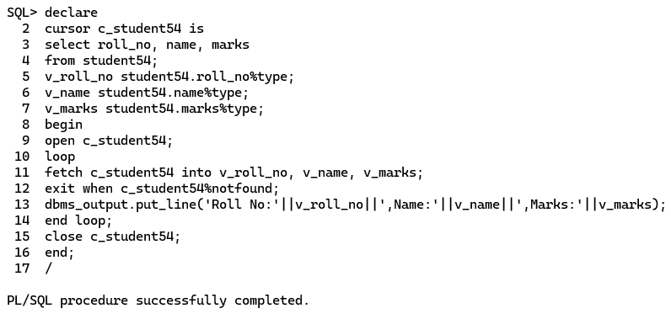

Practical No.8
Aim: Store Procedure- Creating & invoking stored procedure.
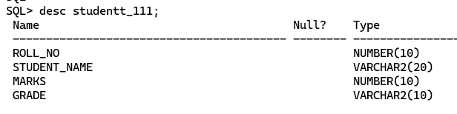
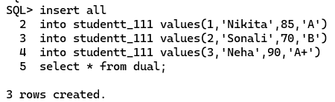
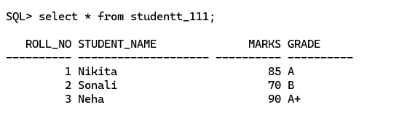
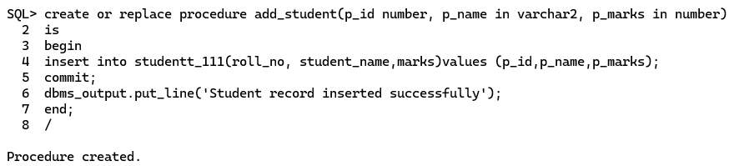
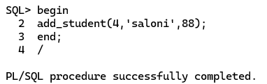
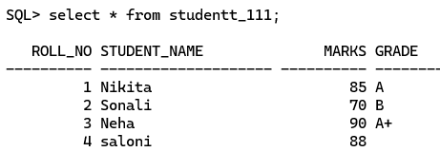
Procedure to Delete Data into Table
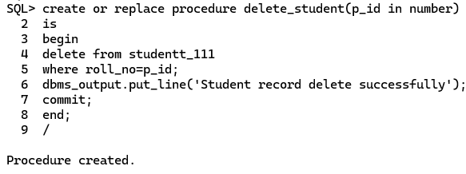
Invoke Procedure
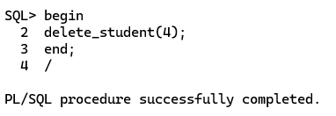
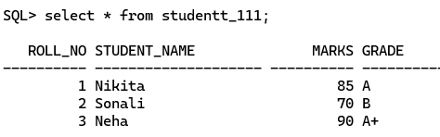
Practical No.9
Aim: Stored Function- Creating invoking function from SQL statement.
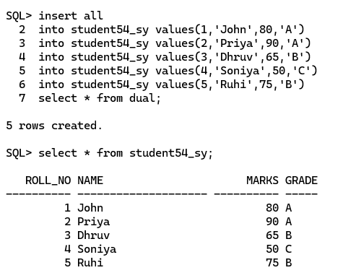
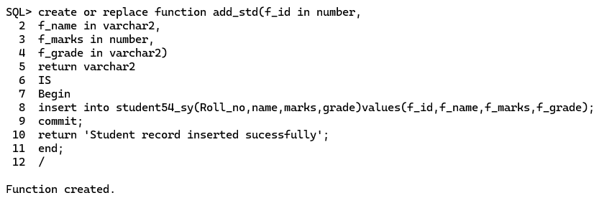
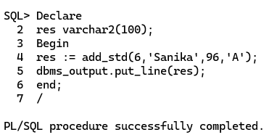
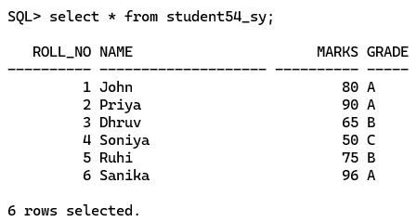

Practical No.10
Aim: Working with Packages.
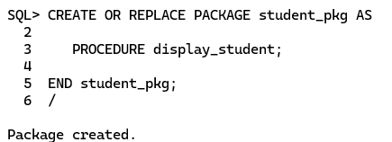
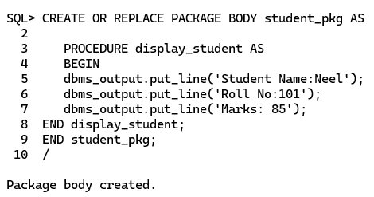
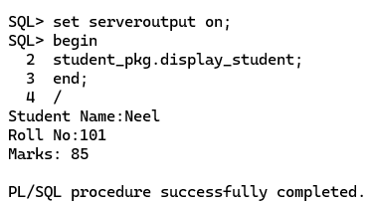

Practical No.11
Aim: Working with large objects and triggers / create row triggers.
